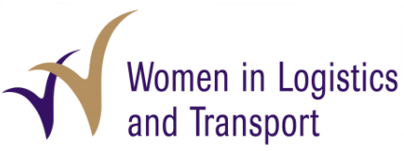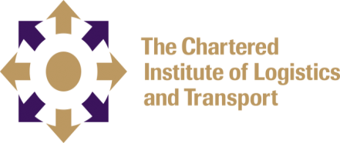
Women in Logistics and Transport (WiLAT) Sri Lanka
Application for Membership

1. Name with Initials : …………………………………………………………………………………………………………………….

2. Full Name : …………………………………………………………………………………………………………….…..….

3. Address : …………………………………………….…………………………………………………….…………….….

…………………………………………..……………………………………………………………….….……

4. Date of Birth : …………………………………………………………………………………………………………….……...

5. NIC No : …………………………………………………………..………………………………………….….…………

6. Work Place : ………………………………………………………………………………………………………..…………..

Designation : ………………………..…………………………………………………………………………………………..

Brief Description of Experience: ……………………………………………………………………………………………………………………

……………………………………………………………………………………………………..…………….

…………………………………………………………………………………………………………………..

Address : ……………………………..…………………………………………………………….……………………….

7. Contact No: Mobile : …………………………………………………………………………………………………………………….

Residential : ……………………………………………………… Official: ………………………………………………

8. Email Address: Personal : …………………………………………………………………………………………………………...…..….

Official : …………………………………………………………………………………………………………....………

9. Are you a CILT Member? : Yes / No

If yes, Membership No : ……………………………………………………………….……………………………………………….…..

10. Please describe in what way you can support us:

………………………………………………………………………………………………………………………………………………………………..….……

………………………………………………………………………………………………………………………………………………….….……

……………………………………………………………………………………………..……………………………………………………………

11. In your opinion what are the areas that WiLAT Should focus:
………………………………………………………………………………………………..………………………………………………………..

…………………………………………………………………………………………………………………………………………………………..

…………………………………………………………………………………………………………………………………………………………..
(Application should accompany with a non-refundable application fee of Rs. 1,000/- for which payment could be made by a cheque or deposited to the Bank of Ceylon City Branch account No.# 0073214339 and the deposit slip be attached to the application. The cheques in relation to this could be drawn in favor of Chartered Institute of Logistics and Transport Sri Lanka and to cross with “Account Payee only”.)
For further details please contact 0115657357/0777579798 or admin@ciltsl.com

